PROJECT REPORT
  VIT BHOPAL UNIVERSITY  SCHOOL OF COMPUTER SCIENCE ENGINEERING AND ARTIFICIAL INTELLIGENCE | NAME: SHUBHAM RAJ  REG. NO.: 26BAI10636  BRANCH: COMPUTER SCIENCE ENGINEERING (AI ML)  SEMESTER: FALL SEMESTER 2026-27  FACULTY NAME: DR. RAJIT NAIR  PROJECT TOPIC:  AIRPORT MANAGEMENT SYSTEM

AIRPORT MANAGEMENT SYSTEM

Project Type: Python GUI Application
Technology Used: Python, Tkinter, ttk
Application Area: Airport and Ticket Management
Interface: Desktop Graphical User Interface

1. Introduction
The Airport Management System is a simple desktop-based application developed in Python using the Tkinter library. The main idea behind the project is to create a small but functional system through which basic airport activities can be handled from one window. Instead of managing flight and passenger information through separate manual records, the application brings the common operations together in a single graphical interface.
The system contains a set of predefined flights and allows a user to view available flights, book a ticket, cancel a ticket, and check passenger information. It also displays basic statistics such as the number of flights, the number of booked passengers, and the total number of available seats. The interface is divided into simple menu options, which makes the application easy to understand and use.
This project was mainly designed as a practical Python application. It demonstrates how object-oriented programming, lists and dictionaries, functions, input validation, GUI widgets, and message boxes can work together in one real-world style program.

2. Problem Statement
Managing flight and passenger details manually can become confusing, especially when bookings and cancellations have to be updated at the same time. For a small airport management simulation, there is a need for a simple system that can keep flight information organized and perform basic ticket operations without requiring complicated software.
The problem addressed by this project is therefore to develop a user-friendly desktop application that can maintain basic flight details, record passenger bookings, update seat availability, process cancellations, and display passenger information. The system should also provide clear messages when the user enters incomplete or invalid information.

3. Functional Requirements
The functional requirements describe what the application is expected to do. Based on the implemented code, the main requirements are:
Display a home page with a welcome message and basic airport statistics.
Display predefined flight details including flight number, airline, source, destination, departure time, and available seats.
Allow the user to enter passenger name, age, and phone number while booking a ticket.
Allow the user to select a flight from a drop-down list.
Validate that required booking fields are not left empty.
Validate that age and phone number contain numeric values.
Check whether seats are available before confirming a booking.
Reduce the selected flight's available seats by one after a successful booking.
Store passenger details in the passenger list.
Display a booking confirmation message after successful booking.
Allow a ticket to be cancelled using the passenger's name.
Restore one available seat when a ticket is cancelled.
Display passenger records along with their associated flight and airline.
Show an error message when a passenger booking cannot be found.
Ask for confirmation before closing the application.

4. Non-Functional Requirements
Usability: The interface should be simple enough that a first-time user can understand the available operations.
Performance: Since the application works with a small in-memory dataset, normal operations such as searching for a passenger or flight should be quick.
Reliability: Booking and cancellation operations should update both passenger records and seat counts consistently.
Validation: The system should prevent obviously incomplete or non-numeric age and phone inputs from being accepted.
Maintainability: The code is organized into separate methods such as show_flights(), book_ticket_window(), cancel_ticket_window(), and show_passengers(), making individual parts easier to modify.
Portability: The application uses Python and Tkinter, so it can run on systems where a compatible Python environment with Tkinter is available.
Data simplicity: The current version does not depend on an external database, which keeps the project easy to set up and demonstrate.

5. Algorithm and Flow Chart
5.1 Main Algorithm
Start the program and create the Tkinter root window.
Create the AirportManagementSystem object.
Load the predefined flight data and create an empty passenger list.
Create the header, navigation menu, main area, and home page.
Wait for the user to select an operation from the menu.
If Flights is selected, display all available flights.
If Book Ticket is selected, collect passenger details and selected flight.
Check whether all fields are filled and whether age and phone number are numeric.
Find the selected flight and check its available seats.
If a seat is available, reduce the seat count by one and add the passenger to the passenger list.
If Cancel Ticket is selected, search for the passenger by name.
If the passenger is found, restore the flight seat and remove the passenger record.
If Passengers is selected, display the stored passenger records.
If Exit is selected, ask for confirmation and close the application if confirmed.
Continue accepting operations until the application is closed.

5.2 Flow Chart
┌─────────────────────┐
│ START │
└──────────┬──────────┘
↓
┌──────────────────────────────┐
│ Create Tkinter window & app │
│ Load flights & empty records │
└──────────────┬───────────────┘
↓
┌──────────────────────────────┐
│ Display Home Page │
└──────────────┬───────────────┘
↓
┌──────────────────────────────┐
│ User selects option │
└───────┬────────┬────────┬────┘
↓ ↓ ↓
Flights Booking Cancel / Passengers / Exit
│ │ │
↓ ↓ ↓
Show flight Validate Perform selected action
details input │
↓ │
Check seats │
↓ │
┌─────┴─────┐ │
│ │ │
Available Full │
│ │ │
↓ ↓ │
Save booking Show error │
Reduce seat │
│ │
└──────────┬───────────────┘
↓
┌─────────────────┐
│ Continue using? │
└───────┬─────────┘
Yes
↓
Back to Menu
│
No
↓
┌─────────────────┐
│ END │
└─────────────────┘

6. Implementation Details
6.1 Technologies and Libraries
Python: Used as the main programming language.
Tkinter: Used to create the desktop graphical user interface.
ttk: Used for enhanced widgets, particularly Treeview tables and Combobox controls.
messagebox: Used for warnings, errors, information messages, and exit confirmation.
6.2 Program Structure
The application is built around the AirportManagementSystem class. The constructor initializes the main window, loads the flight information, creates an empty passenger list, and then builds the different sections of the interface.
The flight information is stored as a list of dictionaries. Each dictionary contains a flight number, airline, source, destination, departure time, and number of available seats. The passenger information is also stored as dictionaries inside a list. This approach is straightforward for a small academic project and makes the data easy to access from the program.
6.3 User Interface
The interface has a fixed 1000 × 650 window with a header at the top and a navigation menu below it. The main menu contains Home, Flights, Book Ticket, Cancel Ticket, Passengers, and Exit. The program clears the main content area before loading a different page, so the user can move between features without opening multiple application windows.

6.4 Flight Management
The Flights page uses a ttk.Treeview table to present flight information in an organized form. The table shows the flight number, airline, origin, destination, departure time, and available seats. The current implementation contains six predefined flights.
6.5 Ticket Booking
During booking, the user enters a passenger name, age, and phone number and selects a flight from a read-only Combobox. The program first checks for missing information. It then checks that age and phone number contain only digits. After identifying the selected flight, the system checks its seat count. If a seat is available, one seat is deducted and the passenger record is added to the passengers list.
6.6 Ticket Cancellation
For cancellation, the user enters a passenger name. The system searches the passenger list without considering uppercase or lowercase differences. If a matching record is found, the corresponding flight's available seat count is increased by one and the passenger record is removed.
6.7 Passenger Display
The Passengers page displays the stored passenger records in another Treeview table. It shows the passenger name, age, phone number, flight number, and airline. If there are no bookings, the application displays a message instead of an empty table.

7. Testing Approach
Testing was planned around the main actions a user can perform in the application. The focus was on checking normal operations as well as common incorrect inputs. Since the program stores its data in memory, testing also checks whether the seat count and passenger list stay synchronized after booking and cancellation.
Test Case | Input / Action | Expected Result | Purpose
Open application | Run the Python file | Home page appears | Check startup
View flights | Click Flights | Flight table is displayed | Check flight display
Valid booking | Enter valid details and select a flight | Booking succeeds and seats decrease | Check core booking logic
Empty booking field | Leave one field blank | Warning is displayed | Check required fields
Invalid age | Enter letters for age | Invalid Age warning appears | Check input validation
Invalid phone | Enter non-numeric phone | Invalid Phone warning appears | Check input validation
Full flight | Attempt booking when seats are zero | Flight Full error appears | Check seat validation
Valid cancellation | Enter an existing passenger name | Ticket is cancelled and seat is restored | Check cancellation
Unknown passenger | Enter a name not in records | Not Found error appears | Check search handling
View passengers | Click Passengers after booking | Passenger record is shown | Check stored data
Exit | Click Exit and confirm | Application closes | Check termination

8. CODE
import tkinter as tk
from tkinter import ttk, messagebox

# -------------------------------------------------------
# AIRPORT MANAGEMENT SYSTEM
# -------------------------------------------------------

class AirportManagementSystem:

def __init__(self, root):
self.root = root
self.root.title("Airport Management System")
self.root.geometry("1000x650")
self.root.resizable(False, False)

# ---------------- FLIGHT DATA ----------------
self.flights = [
{
"number": "AI101",
"airline": "Air India",
"source": "Delhi",
"destination": "Mumbai",
"time": "08:30 AM",
"seats": 45
},
{
"number": "6E202",
"airline": "IndiGo",
"source": "Mumbai",
"destination": "Bangalore",
"time": "11:45 AM",
"seats": 38
},
{
"number": "UK303",
"airline": "Vistara",
"source": "Delhi",
"destination": "Kolkata",
"time": "02:15 PM",
"seats": 28
},
{
"number": "SG404",
"airline": "SpiceJet",
"source": "Hyderabad",
"destination": "Delhi",
"time": "05:30 PM",
"seats": 32
},
{
"number": "6E505",
"airline": "IndiGo",
"source": "Bangalore",
"destination": "Chennai",
"time": "08:00 PM",
"seats": 40
},
{
"number": "AI606",
"airline": "Air India",
"source": "Chennai",
"destination": "Delhi",
"time": "09:45 PM",
"seats": 25
}
]

self.passengers = []

self.create_header()
self.create_menu()
self.create_main_area()
self.show_home()

# -------------------------------------------------------
# HEADER
# -------------------------------------------------------

def create_header(self):

header = tk.Frame(self.root, bg="#17365D", height=80)
header.pack(fill="x")
header.pack_propagate(False)

title = tk.Label(
header,
text="✈ AIRPORT MANAGEMENT SYSTEM",
font=("Arial", 22, "bold"),
bg="#17365D",
fg="white"
)
title.pack(pady=20)

# -------------------------------------------------------
# MENU
# -------------------------------------------------------

def create_menu(self):

menu = tk.Frame(self.root, bg="#EAF2F8", height=55)
menu.pack(fill="x")

buttons = [
("Home", self.show_home),
("Flights", self.show_flights),
("Book Ticket", self.book_ticket_window),
("Cancel Ticket", self.cancel_ticket_window),
("Passengers", self.show_passengers),
("Exit", self.exit_program)
]

for text, command in buttons:

button = tk.Button(
menu,
text=text,
command=command,
font=("Arial", 10, "bold"),
bg="white",
fg="#17365D",
relief="flat",
padx=18,
pady=8,
cursor="hand2"
)

button.pack(side="left", padx=5, pady=8)

# -------------------------------------------------------
# MAIN AREA
# -------------------------------------------------------

def create_main_area(self):

self.main_frame = tk.Frame(
self.root,
bg="white"
)

self.main_frame.pack(
fill="both",
expand=True,
padx=20,
pady=20
)

def clear_main(self):

for widget in self.main_frame.winfo_children():
widget.destroy()

# -------------------------------------------------------
# HOME PAGE
# -------------------------------------------------------

def show_home(self):

self.clear_main()

welcome = tk.Label(
self.main_frame,
text="Welcome to the Airport Management System",
font=("Arial", 20, "bold"),
bg="white",
fg="#17365D"
)
welcome.pack(pady=30)

info = tk.Label(
self.main_frame,
text=(
"Manage flights, book tickets, cancel reservations\n"
"and view passenger information easily."
),
font=("Arial", 13),
bg="white",
fg="#555555",
justify="center"
)
info.pack(pady=10)

# Statistics
stats_frame = tk.Frame(
self.main_frame,
bg="white"
)
stats_frame.pack(pady=40)

total_flights = len(self.flights)
total_passengers = len(self.passengers)

available_seats = sum(
flight["seats"] for flight in self.flights
)

self.create_stat_card(
stats_frame,
"TOTAL FLIGHTS",
total_flights,
0
)

self.create_stat_card(
stats_frame,
"PASSENGERS",
total_passengers,
1
)

self.create_stat_card(
stats_frame,
"AVAILABLE SEATS",
available_seats,
2
)

# -------------------------------------------------------
# STAT CARD
# -------------------------------------------------------

def create_stat_card(self, parent, title, value, column):

card = tk.Frame(
parent,
bg="#F4F6F7",
width=220,
height=120,
relief="ridge",
bd=1
)

card.grid(
row=0,
column=column,
padx=15
)

card.pack_propagate(False)

tk.Label(
card,
text=title,
font=("Arial", 10, "bold"),
bg="#F4F6F7",
fg="#666666"
).pack(pady=(20, 5))

tk.Label(
card,
text=str(value),
font=("Arial", 24, "bold"),
bg="#F4F6F7",
fg="#17365D"
).pack()

# -------------------------------------------------------
# FLIGHT PAGE
# -------------------------------------------------------

def show_flights(self):

self.clear_main()

tk.Label(
self.main_frame,
text="Available Flights",
font=("Arial", 18, "bold"),
bg="white",
fg="#17365D"
).pack(anchor="w", pady=(0, 15))

columns = (
"number",
"airline",
"source",
"destination",
"time",
"seats"
)

table = ttk.Treeview(
self.main_frame,
columns=columns,
show="headings",
height=18
)

table.heading("number", text="Flight No.")
table.heading("airline", text="Airline")
table.heading("source", text="From")
table.heading("destination", text="To")
table.heading("time", text="Departure")
table.heading("seats", text="Available Seats")

table.column("number", width=100)
table.column("airline", width=150)
table.column("source", width=130)
table.column("destination", width=130)
table.column("time", width=130)
table.column("seats", width=130)

for flight in self.flights:

table.insert(
"",
"end",
values=(
flight["number"],
flight["airline"],
flight["source"],
flight["destination"],
flight["time"],
flight["seats"]
)
)

table.pack(fill="both", expand=True)

# -------------------------------------------------------
# BOOK TICKET
# -------------------------------------------------------

def book_ticket_window(self):

self.clear_main()

tk.Label(
self.main_frame,
text="Book a Flight Ticket",
font=("Arial", 18, "bold"),
bg="white",
fg="#17365D"
).pack(anchor="w", pady=(0, 20))

form = tk.Frame(
self.main_frame,
bg="white"
)
form.pack()

# Name
tk.Label(
form,
text="Passenger Name:",
font=("Arial", 11),
bg="white"
).grid(row=0, column=0, padx=10, pady=10, sticky="w")

name_entry = tk.Entry(
form,
width=35,
font=("Arial", 11)
)
name_entry.grid(row=0, column=1, pady=10)

# Age
tk.Label(
form,
text="Age:",
font=("Arial", 11),
bg="white"
).grid(row=1, column=0, padx=10, pady=10, sticky="w")

age_entry = tk.Entry(
form,
width=35,
font=("Arial", 11)
)
age_entry.grid(row=1, column=1, pady=10)

# Phone
tk.Label(
form,
text="Phone Number:",
font=("Arial", 11),
bg="white"
).grid(row=2, column=0, padx=10, pady=10, sticky="w")

phone_entry = tk.Entry(
form,
width=35,
font=("Arial", 11)
)
phone_entry.grid(row=2, column=1, pady=10)

# Flight selection
tk.Label(
form,
text="Select Flight:",
font=("Arial", 11),
bg="white"
).grid(row=3, column=0, padx=10, pady=10, sticky="w")

flight_options = [
f"{flight['number']} - {flight['airline']} "
f"({flight['source']} → {flight['destination']})"
for flight in self.flights
]

flight_combo = ttk.Combobox(
form,
values=flight_options,
width=32,
state="readonly"
)
flight_combo.grid(row=3, column=1, pady=10)

# Book button
def confirm_booking():

name = name_entry.get().strip()
age = age_entry.get().strip()
phone = phone_entry.get().strip()
selected = flight_combo.get()

if not name or not age or not phone or not selected:
messagebox.showwarning(
"Missing Information",
"Please fill in all the details."
)
return

if not age.isdigit():
messagebox.showwarning(
"Invalid Age",
"Please enter a valid age."
)
return

if not phone.isdigit():
messagebox.showwarning(
"Invalid Phone",
"Please enter a valid phone number."
)
return

flight_no = selected.split(" - ")[0]

selected_flight = None

for flight in self.flights:

if flight["number"] == flight_no:
selected_flight = flight
break

if selected_flight["seats"] <= 0:

messagebox.showerror(
"Flight Full",
"Sorry, no seats are available on this flight."
)

return

selected_flight["seats"] -= 1

passenger = {
"name": name,
"age": age,
"phone": phone,
"flight": flight_no
}

self.passengers.append(passenger)

messagebox.showinfo(
"Booking Successful",
f"Ticket booked successfully!\n\n"
f"Passenger: {name}\n"
f"Flight: {flight_no}\n"
f"Airline: {selected_flight['airline']}\n"
f"Route: {selected_flight['source']} → "
f"{selected_flight['destination']}"
)

self.show_home()

tk.Button(
self.main_frame,
text="BOOK TICKET",
command=confirm_booking,
font=("Arial", 11, "bold"),
bg="#17365D",
fg="white",
width=20,
pady=10,
relief="flat",
cursor="hand2"
).pack(pady=25)

# -------------------------------------------------------
# CANCEL TICKET
# -------------------------------------------------------

def cancel_ticket_window(self):

self.clear_main()

tk.Label(
self.main_frame,
text="Cancel Ticket",
font=("Arial", 18, "bold"),
bg="white",
fg="#17365D"
).pack(anchor="w", pady=(0, 25))

box = tk.Frame(
self.main_frame,
bg="white"
)
box.pack()

tk.Label(
box,
text="Passenger Name:",
font=("Arial", 11),
bg="white"
).grid(row=0, column=0, padx=10, pady=10)

name_entry = tk.Entry(
box,
width=35,
font=("Arial", 11)
)
name_entry.grid(row=0, column=1, pady=10)

def cancel():

name = name_entry.get().strip()

if not name:

messagebox.showwarning(
"Enter Name",
"Please enter the passenger name."
)

return

found_passenger = None

for passenger in self.passengers:

if passenger["name"].lower() == name.lower():
found_passenger = passenger
break

if found_passenger is None:

messagebox.showerror(
"Not Found",
"No booking was found for this passenger."
)

return

flight_number = found_passenger["flight"]

for flight in self.flights:

if flight["number"] == flight_number:
flight["seats"] += 1
break

self.passengers.remove(found_passenger)

messagebox.showinfo(
"Ticket Cancelled",
"The ticket has been cancelled successfully."
)

self.show_home()

tk.Button(
self.main_frame,
text="CANCEL TICKET",
command=cancel,
font=("Arial", 11, "bold"),
bg="#A93226",
fg="white",
width=20,
pady=10,
relief="flat",
cursor="hand2"
).pack(pady=25)

# -------------------------------------------------------
# PASSENGER PAGE
# -------------------------------------------------------

def show_passengers(self):

self.clear_main()

tk.Label(
self.main_frame,
text="Passenger Details",
font=("Arial", 18, "bold"),
bg="white",
fg="#17365D"
).pack(anchor="w", pady=(0, 15))

if len(self.passengers) == 0:

tk.Label(
self.main_frame,
text="No tickets have been booked yet.",
font=("Arial", 12),
bg="white",
fg="#777777"
).pack(pady=80)

return

columns = (
"name",
"age",
"phone",
"flight",
"airline"
)

table = ttk.Treeview(
self.main_frame,
columns=columns,
show="headings",
height=18
)

table.heading("name", text="Passenger Name")
table.heading("age", text="Age")
table.heading("phone", text="Phone")
table.heading("flight", text="Flight")
table.heading("airline", text="Airline")

table.column("name", width=200)
table.column("age", width=80)
table.column("phone", width=160)
table.column("flight", width=100)
table.column("airline", width=150)

for passenger in self.passengers:

flight_name = ""

for flight in self.flights:

if flight["number"] == passenger["flight"]:
flight_name = flight["airline"]
break

table.insert(
"",
"end",
values=(
passenger["name"],
passenger["age"],
passenger["phone"],
passenger["flight"],
flight_name
)
)

table.pack(fill="both", expand=True)

# -------------------------------------------------------
# EXIT
# -------------------------------------------------------

def exit_program(self):

result = messagebox.askyesno(
"Exit",
"Are you sure you want to exit?"
)

if result:
self.root.destroy()

# -------------------------------------------------------
# MAIN PROGRAM
# -------------------------------------------------------

root = tk.Tk()

app = AirportManagementSystem(root)

root.mainloop()
9. OUTPUT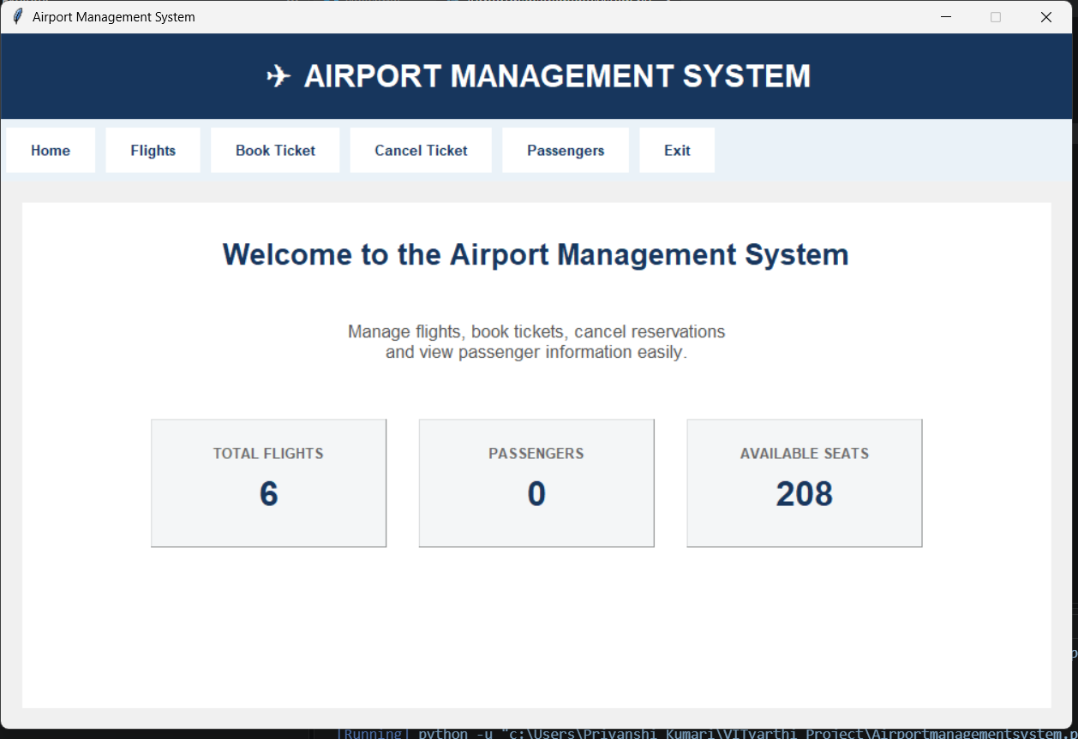
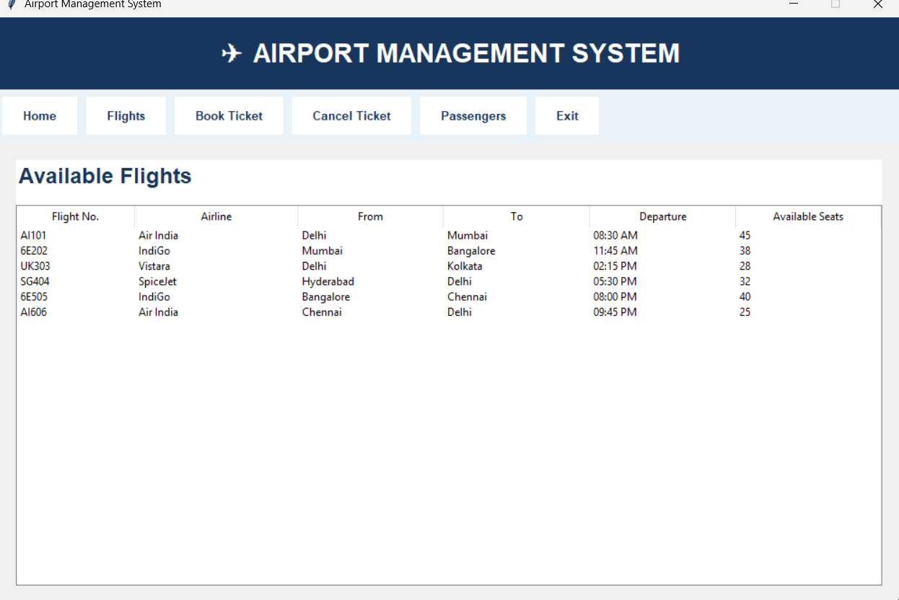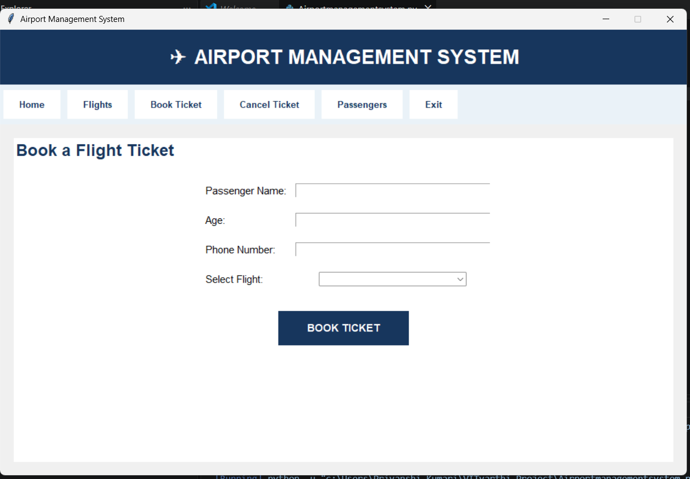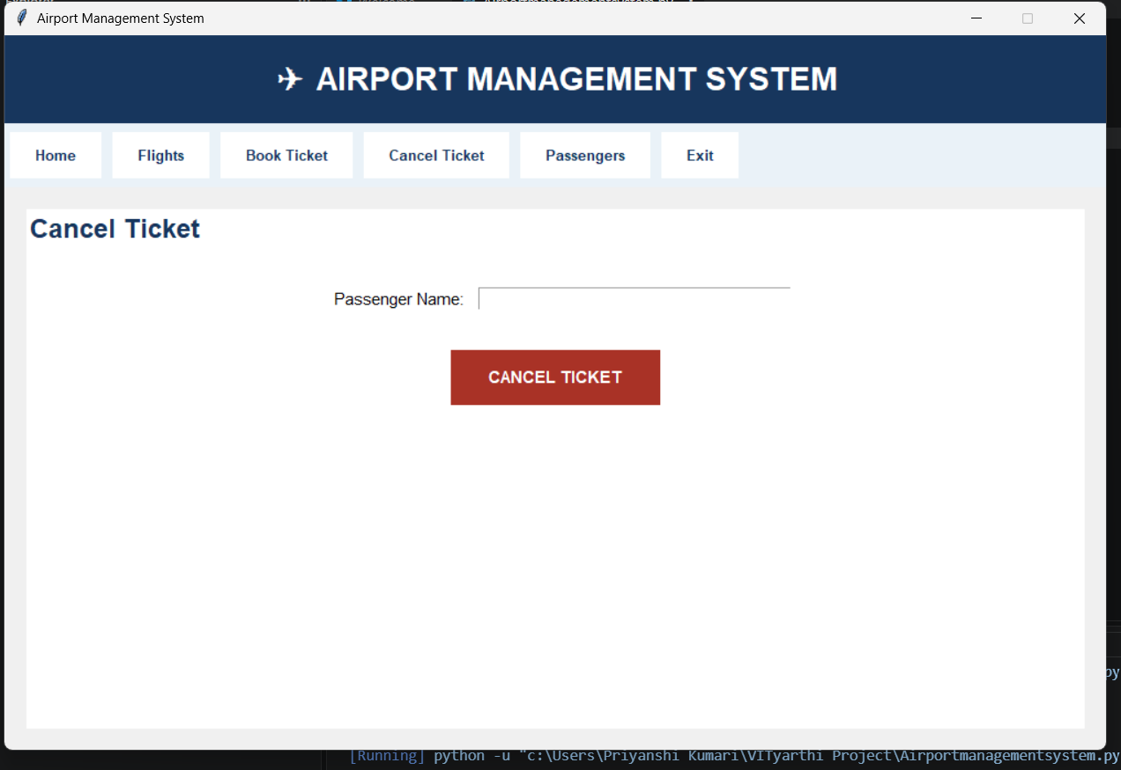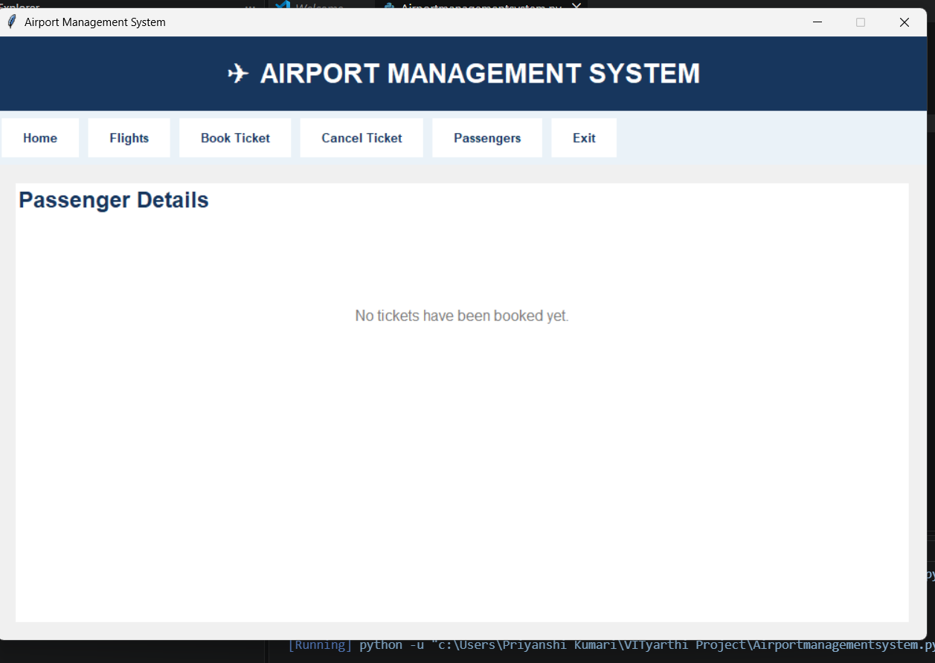
- FILLING PASSENGER DETAILS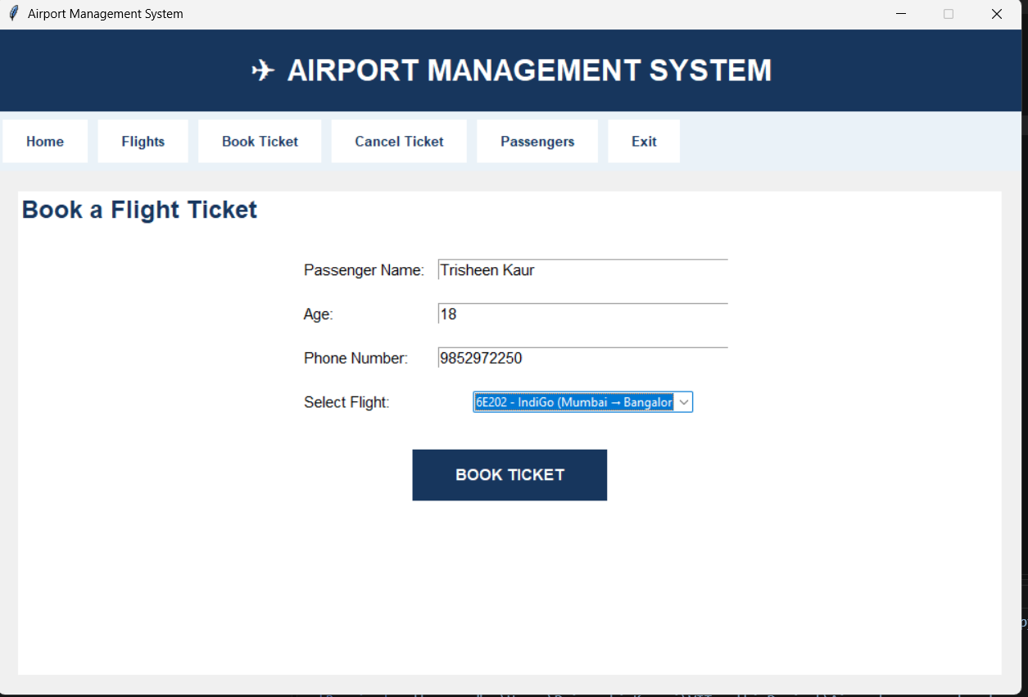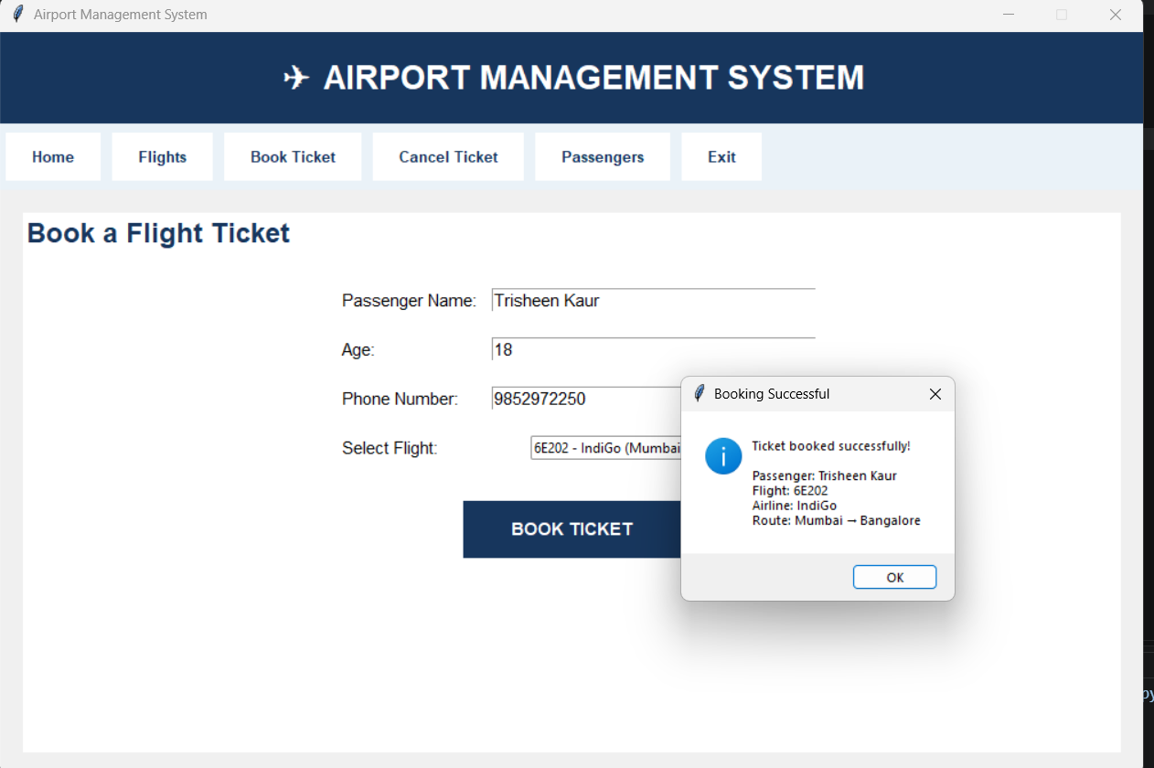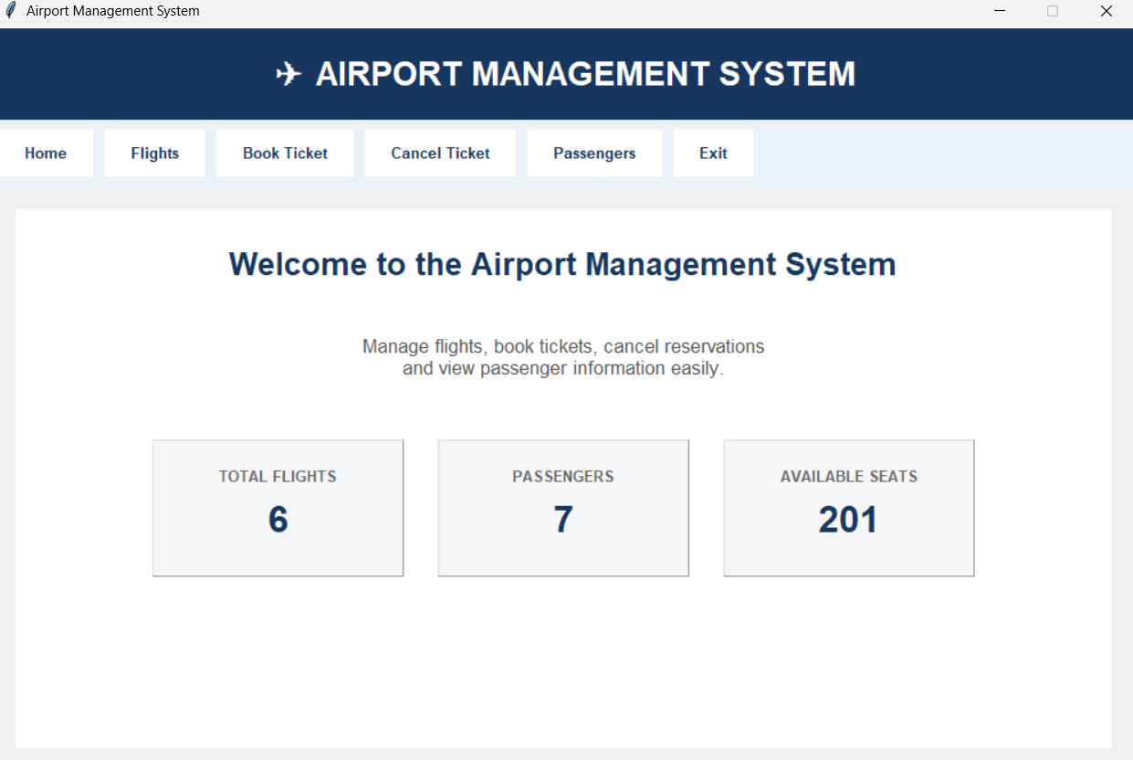

After filling the details, canceling one ticket 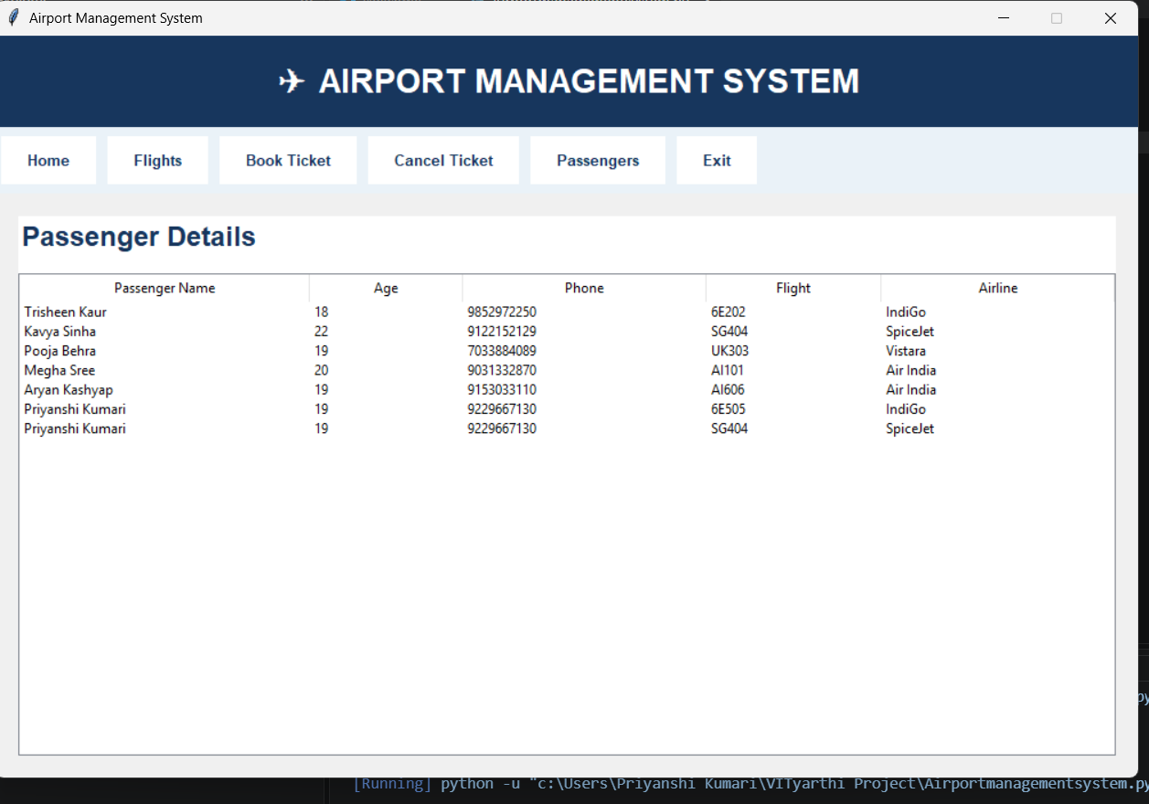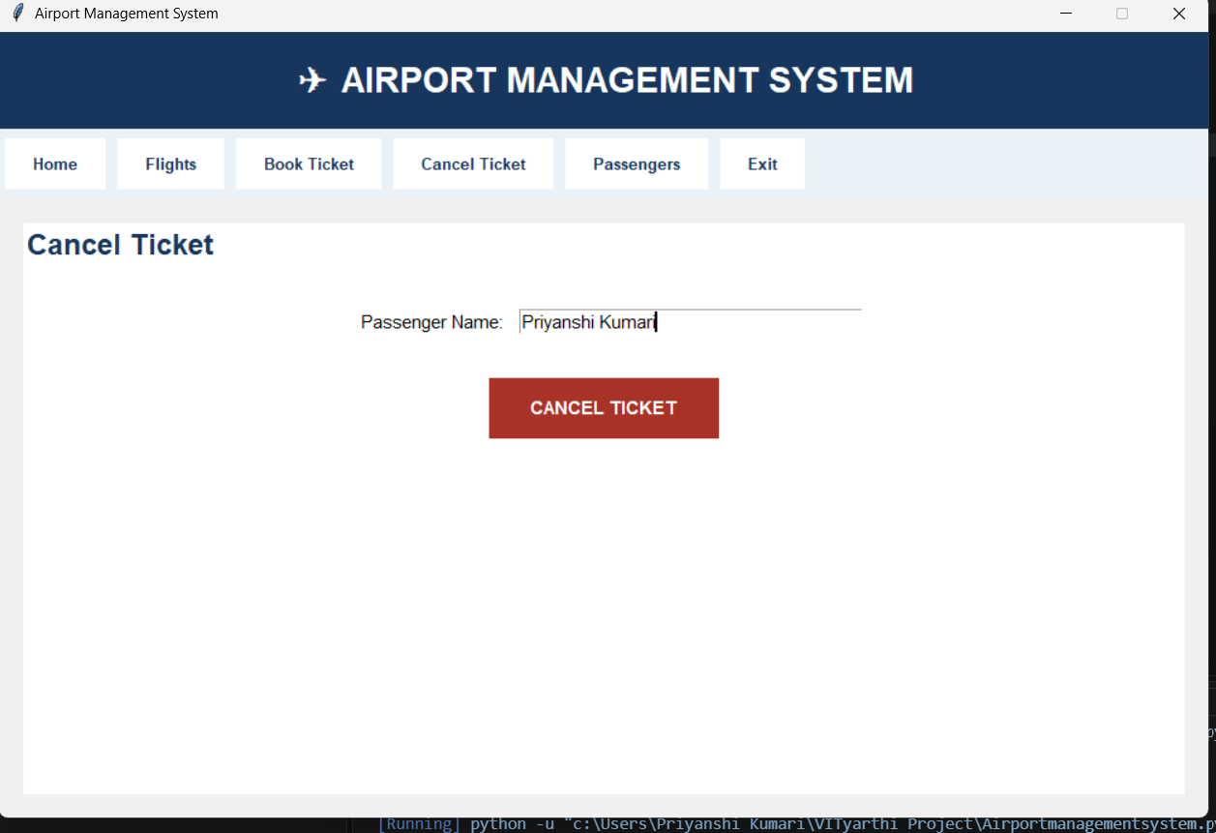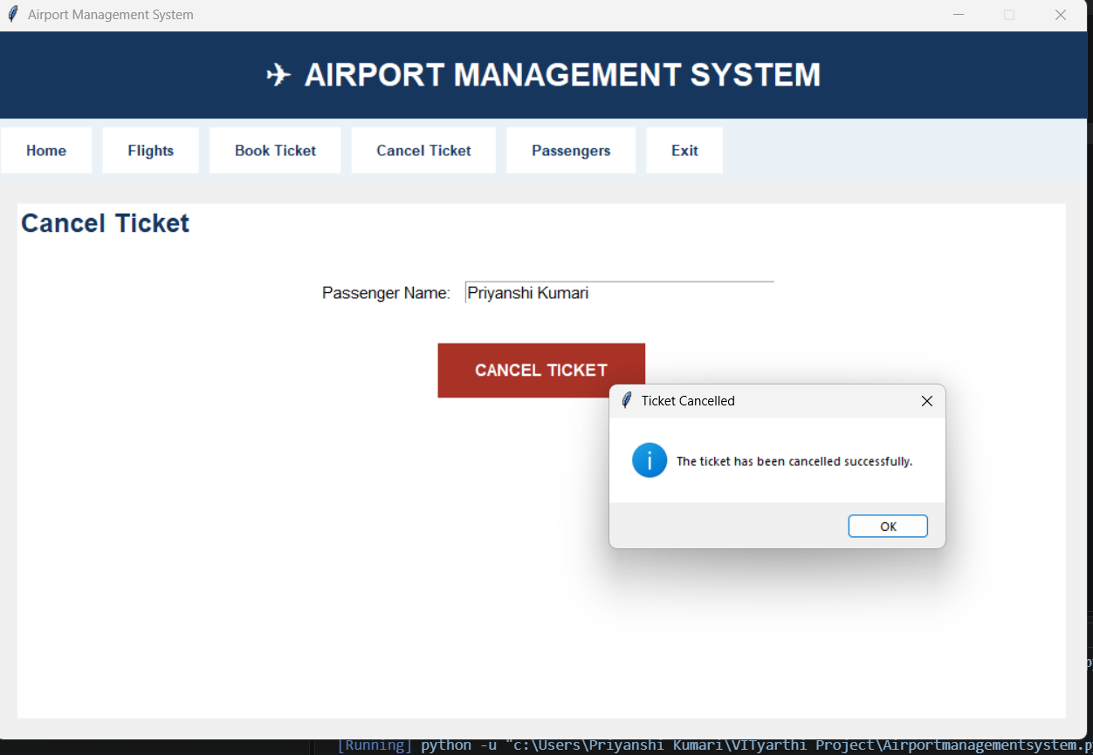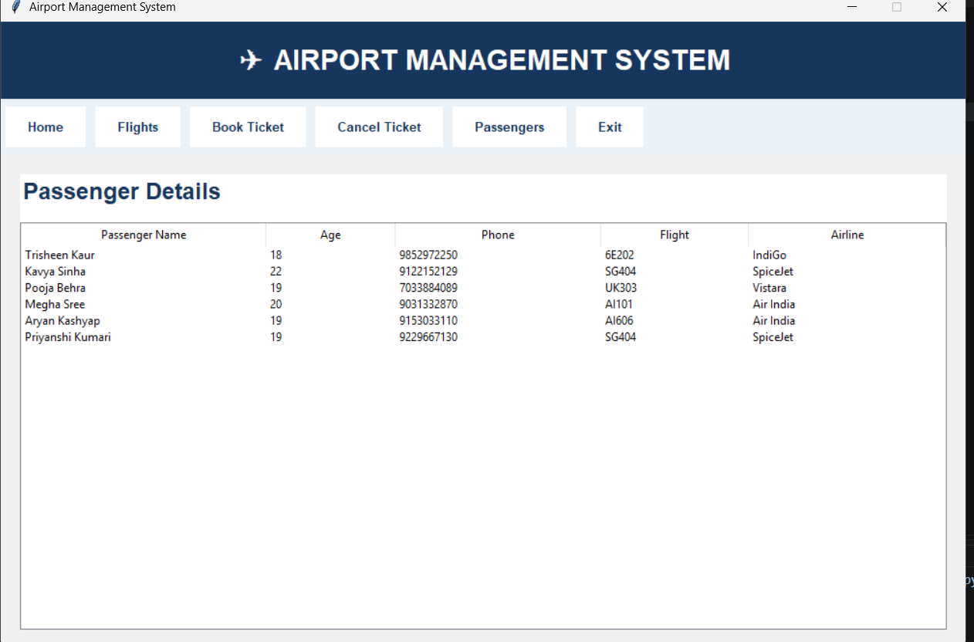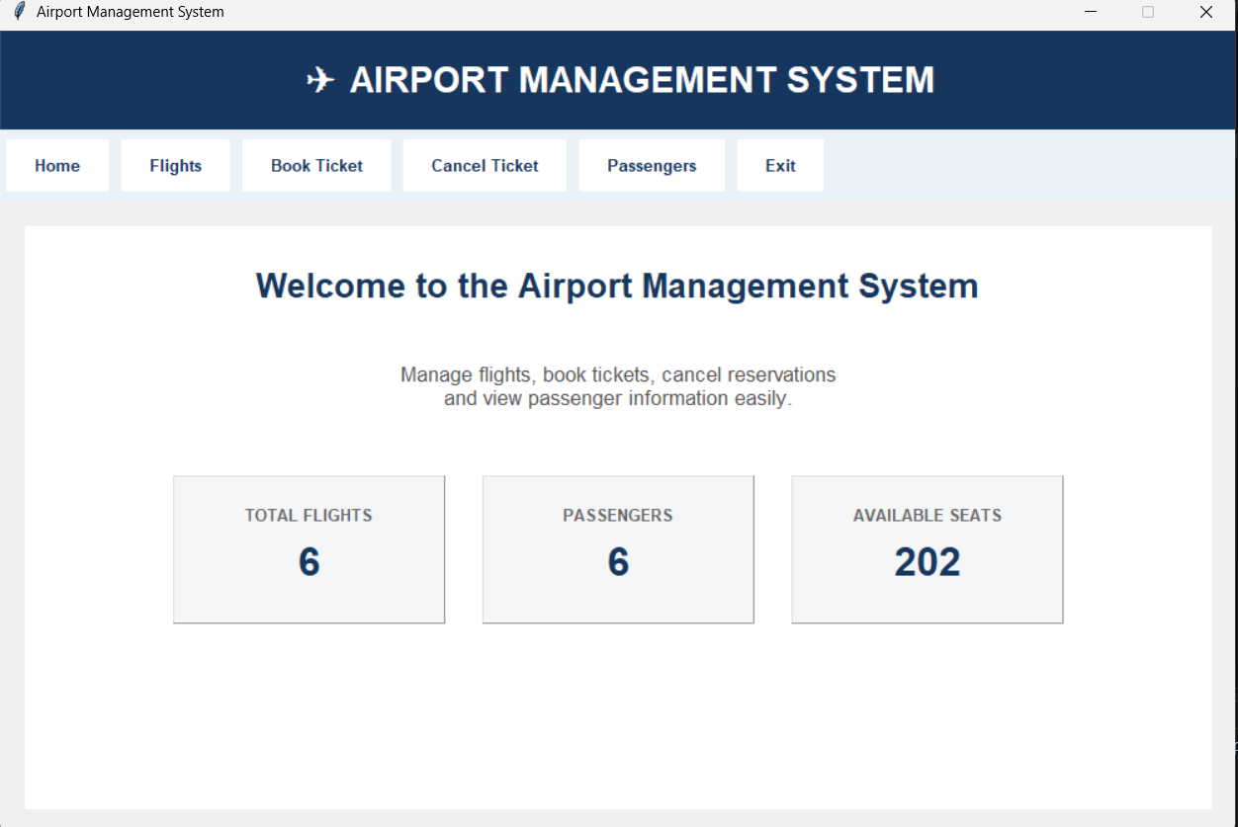
- Exiting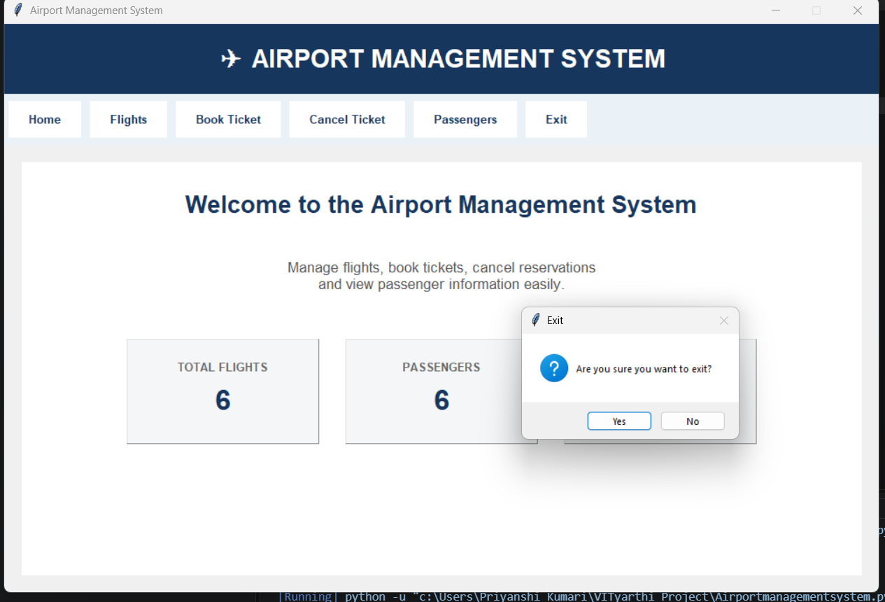
- Run time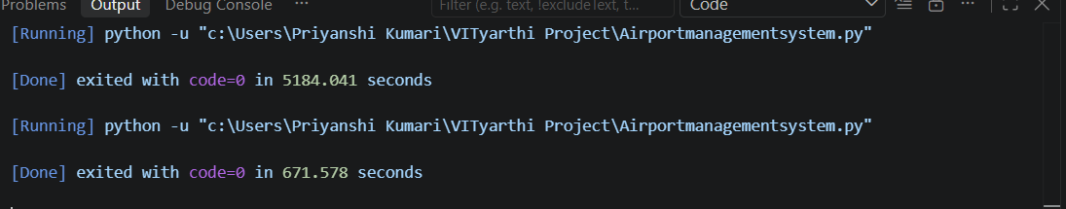

10. GITHUB LINK
rajshubham-eng/AIRPORT-MANAGEMENT-SYSTEM: A command-line Airport Management System in Python. It manages flights, books and cancels tickets with unique IDs, and reports seat occupancy. Features input validation, JSON storage, logging, a modular design and 52 automated tests. Runs with one command: python main.py. Uses only the standard library.

11. Challenges Faced
One of the main challenges in developing this project was keeping the graphical interface and the underlying data connected properly. For example, booking a ticket is not just a matter of showing a success message. The selected flight's seat count also has to be reduced and the passenger has to be added to the records.
Another challenge was handling incorrect user input. A user may leave a field blank or enter letters where a numeric value is expected. The program therefore includes separate validation checks and message boxes so that the application does not proceed with incomplete booking information.
Ticket cancellation also requires two related updates. The passenger record has to be removed while the seat previously occupied by that passenger has to be made available again. Finding the correct flight and passenger and keeping these two changes synchronized is an important part of the logic.
Designing the interface in a clean way was another practical challenge. The program uses a shared main frame and clears its existing widgets before displaying another section. This keeps the application within one window while still giving the user the feeling of moving between different pages.

12. Learning and Key Takeaways
Learned how to build a functional desktop GUI using Python Tkinter.
Understood how classes and methods can be used to organize a larger Python program.
Practiced storing structured information using lists and dictionaries.
Learned how GUI events such as button clicks can trigger specific functions.
Understood the importance of input validation in interactive applications.
Learned how booking and cancellation can be connected to seat availability.
Practiced using Treeview to present records in a table format.
Learned how message boxes can improve user feedback and error handling.
Got practical experience in breaking a project into smaller functions instead of putting all logic in one block.
Understood that even a small application needs testing for both successful and unsuccessful user actions.

13. Limitations and Possible Future Improvements
The current application is intentionally simple and is suitable as a learning project. Its data is stored only in memory, so all passenger bookings are lost when the application is closed. The flight list is also predefined rather than being managed through a database.
In a future version, the project could be expanded by adding a database such as SQLite or MySQL, user login and administrator access, dynamic flight creation and deletion, passenger search, booking IDs, date-wise flight schedules, printable tickets, and stronger validation for phone numbers and other passenger information.

14. Conclusion
The Airport Management System successfully demonstrates how Python can be used to create a practical desktop application with a graphical interface. The project covers the basic workflow of viewing flights, booking tickets, cancelling bookings, and viewing passenger information. Although it does not attempt to model every feature of a real airport system, it provides a clear foundation for understanding GUI programming, data handling, validation, and event-driven programming.
Overall, the project was useful because it connected Python concepts learned in isolation with a complete working application. The result is a simple system that is easy to operate, easy to explain, and can be extended further as more advanced programming concepts are learned.

15. Source Code Reference
This report was prepared directly from the supplied Airport Management System Python source code. The implementation uses the AirportManagementSystem class, predefined flight dictionaries, an in-memory passengers list, Tkinter widgets, ttk tables, Combobox selection, validation checks, and message boxes. The source also defines the main program entry point using tk.Tk() and root.mainloop().

